Two Sides North America – New May 2026 Social Content to Share

Below are a few key posts from Two Sides North America and Love Paper for May. We have highlighted the dates that we will share the posts for reference. We have also shifted many of our posts to the 1080 x 1350 resolution, or the 4:5 ratio, now used for IG and FB. Please feel free to cut and paste the content to share this information with your own social channels. We have included the relevant links and hashtags, and the posts can be edited to fit your style and tone. Please remember to tag us in your post!
X (Twitter): @TwoSidesNA
LinkedIn: @TwoSidesNA or @LovepaperCampaign
Instagram: @TwoSidesNA or @LovePaperCampaign
Facebook: @TwoSidesNorthAmerica or @LovePaperCampaign

Note: Right-click the images and choose Save as Picture
Days to note this month:
Get Caught Reading Month – May 1-31 National Notebook Day – May 15
National Teacher Week – May 6 National Love a Tree Day – May 16
Mother’s Day – May 10 Memorial Day – May 25
National Stationery Week – May 11-15 National Paper Airplane Day – May 26

Post Date | Channel | Text | Image/ video link
May 4th  TSNA | LinkedIn  Twitter  Facebook | The 2025 report from the USPS Office of Inspector General, Comparative Study of International Postal Models (USPS OIG, Feb 2025), compares the Postal Service against 25 foreign postal operators, examining how different regulatory frameworks, business freedoms, and strategies are affecting financial sustainability.  Read the top takeaways from the report here:  https://twosidesna.org/in-the-post/  #usps #postal #paperfacts #mail | 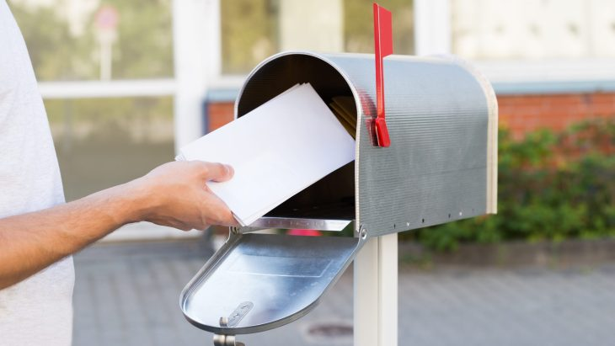
May 4th  LP | LinkedIn  Instagram  Facebook | Soft on your skin. Gentle on the planet. 🌿  Paper tissue is a simple choice that makes a big difference. When sustainably sourced, they are responsible, renewable and recyclable. Because everyday comfort shouldn’t come at the environment’s expense.  Choose paper. Choose better. 💚  https://lovepaperna.org/  #LovePaper | 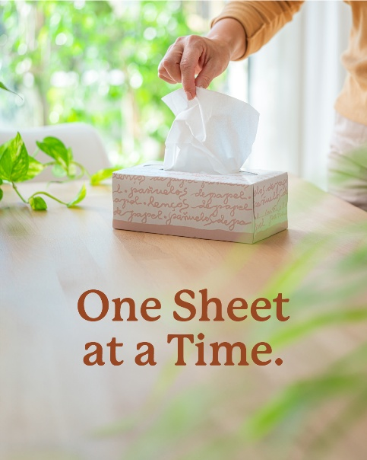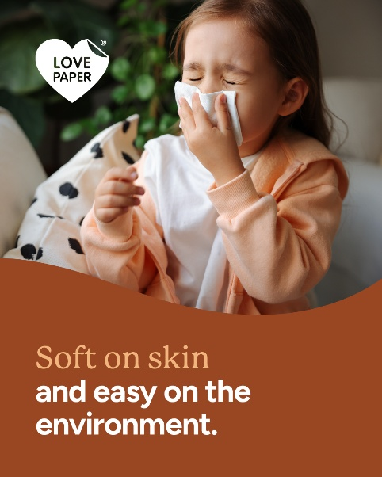
May 6th  TSNA | X (Twitter)  Instagram  Facebook  LinkedIn | 🍎📚 Happy National Teacher Appreciation Day!  Today, we celebrate the educators who inspire curiosity, creativity, and a lifelong love of learning. From printed books to handwritten essays, paper plays a powerful role in the classroom, helping students focus, retain information, and engage more deeply.  Teachers know...sometimes the simplest tools make the biggest impact.  Thank you for everything you do to shape the next generation.  #TeacherAppreciationDay #ThankATeacher #LovePaper #EducationMatters | 
May 7th  TSNA | X (Twitter)  Instagram  Facebook  LinkedIn | Going paperless isn’t always greener.  Digital communication has a real environmental footprint—think energy use, data centers, and e-waste. Meanwhile, paper is renewable, recyclable, and part of a circular economy.  It’s not paper or digital—it’s about smart choices. Learn more about the environmental impact of electronic communications.  https://twosidesna.org/resources/tsna/EComms-Myths-Facts-Sheet.pdf  #PrintVsDigital #SustainabilityMatters | 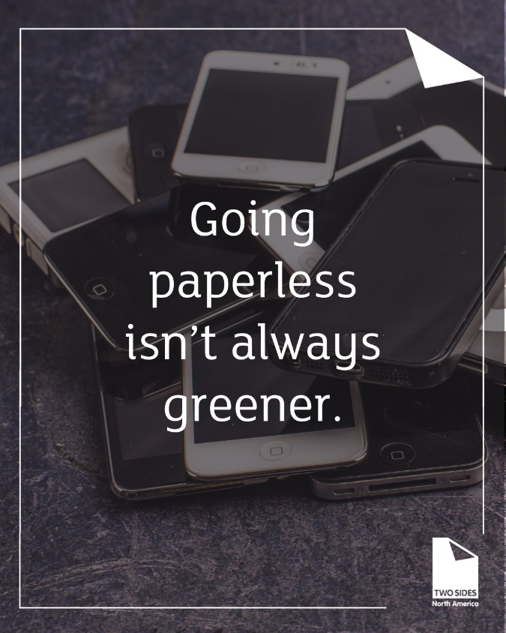
May 8th  TSNA | X (Twitter)  Instagram  Facebook  LinkedIn | The @TwoSidesNA Trend Tracker Survey reveals that 64% of Canadian consumers worry about the security of their electronic personal information.  Discover more and check out the #paperfacts: https://twosidesna.org/trend-tracker-2025/  #cybersecurity #paper | 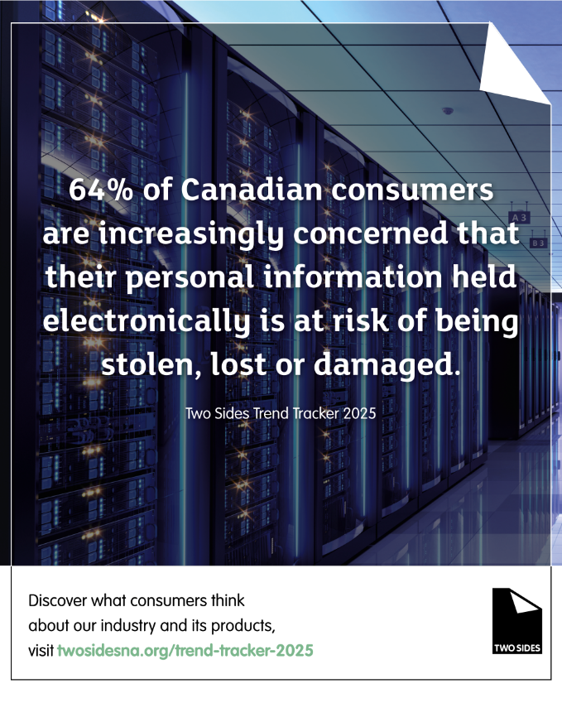
May 11th  LP | LinkedIn  Instagram  Facebook | Get ready to unleash your creativity! 🖊️📚  National Stationery Week is here, and it's time to celebrate all things paper, pens, and productivity. How are you getting organized? Share your favorite stationery items with us!  #NationalStationeryWeek #StationeryLove | 
May 12th  TSNA | X (Twitter)  Instagram  Facebook  LinkedIn | Print preferences aren't fading — they're holding strong. 📄  The @TwoSidesNA 2025 Trend Tracker survey of 12,400 global consumers shows steady demand for print across books, magazines, and financial documents. And while misconceptions about paper's environmental impact persist, we're seeing gradual progress.  The story of paper is a good one. We just need to keep telling it.  Explore the full findings at www.twosidesna.org  #PrintMedia #TwoSidesNA #LovePaper #Sustainability | 
May 13  TSNA | Facebook  LinkedIn  X (Twitter)  Instagram | Discover why paper and cardboard check all the boxes for consumers.  Better for the environment✅  Biodegradable✅  Easy to recycle✅  Dive into the latest insights with the @TwoSidesNA Trend Tracker Survey  https://twosidesna.org/trend-tracker-2025/  #paper #paperfacts #recycle #cardboard | 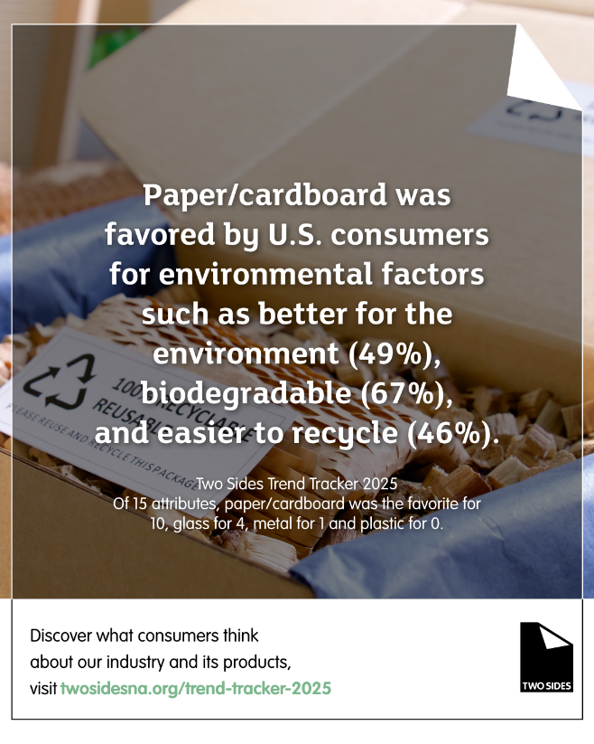
May 13th  LP | Instagram  Facebook  LinkedIn | 📄 Know the facts: Paper is one of the most recycled materials in the U.S.—with 60–64% of paper getting a second life (the recycling rate is even higher for cardboard).  From boxes to books, paper keeps the cycle going—and we’re here for it. We love paper!  Learn more: https://lovepaperna.org/fact-file/paper-revolution/ | 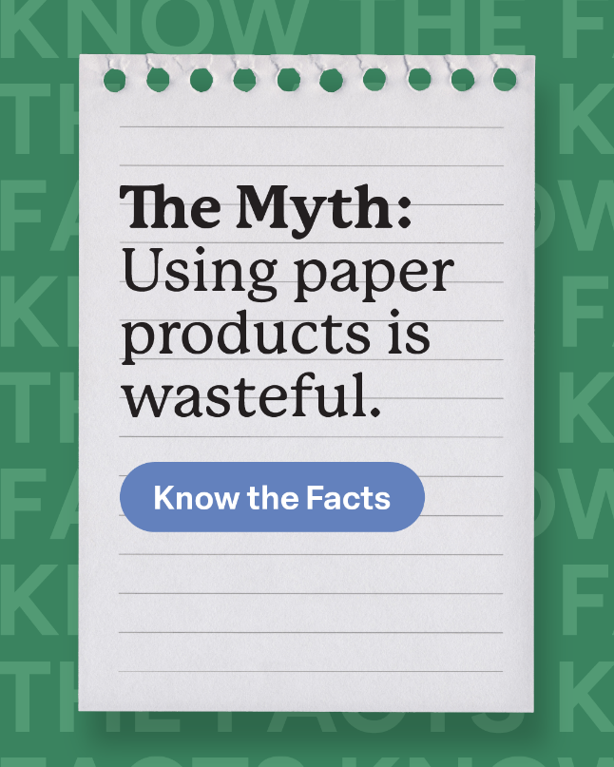
May 15th  TSNA | X (Twitter)  Instagram  Facebook  LinkedIn | While 67% of U.S. forestland is legally available for harvesting, tree cutting and removal occur on less than 2% of forestland each year. Which is less than natural events like insects, disease and fire.  Get more #paperfacts: https://twosidesna.org/unitedstates-forests-renewable-natural/  #forest #forestmanagement #twosides | 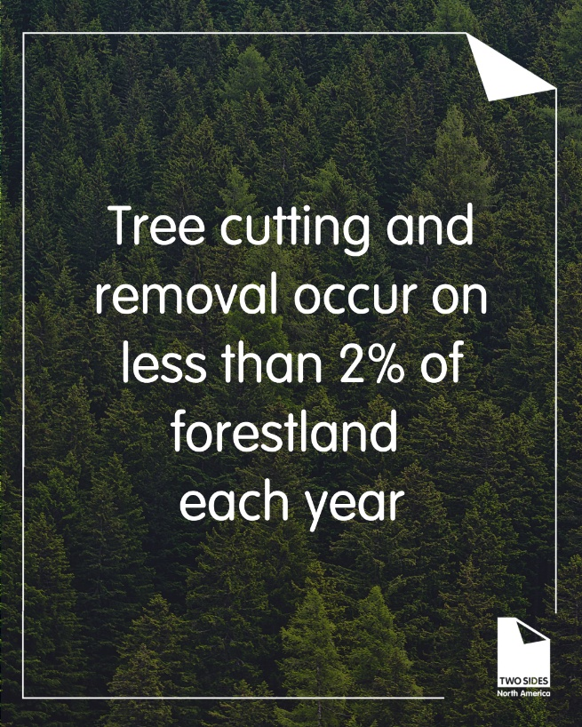
May 16th  LP | Facebook  Instagram  LinkedIn | Happy Love a Tree Day! 💚🌳 Paper Loves Trees!  Trees do so much for our planet—and when responsibly managed, they also help create renewable, recyclable paper products we rely on every day.  By choosing paper, you’re supporting sustainably managed forests and the cycle of planting, growing, and replanting trees for future generations.  #LoveATreeDay #LovePaper #SustainableForestry #PaperFacts | 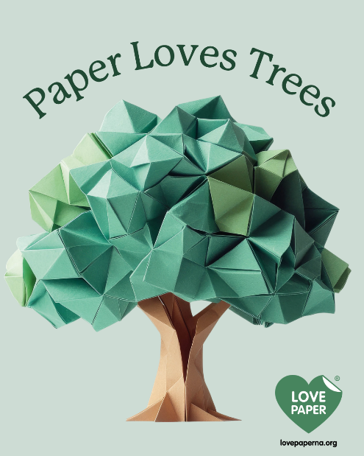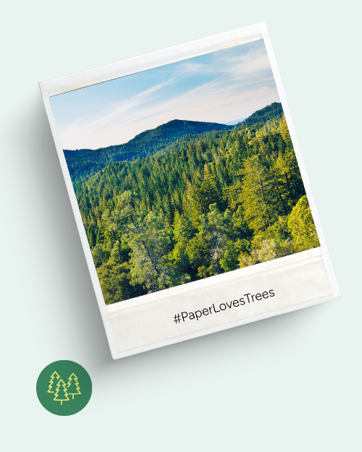
May 19th  LP | Facebook  Instagram  LinkedIn | Paper is simple. Paper is smart. Paper is sustainable.  From renewable resources to high recycling rates, paper proves that everyday choices can make a real difference. Choose a material that works with the planet—not against it.  #LovePaper #SustainableChoices | 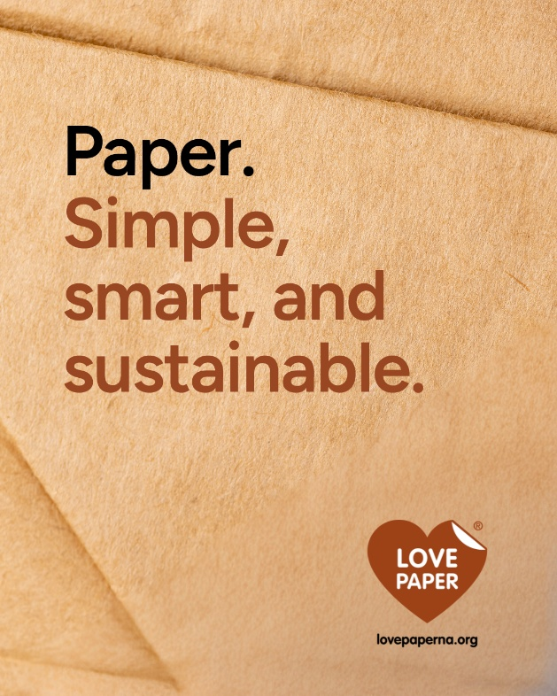
May 20  TSNA | X (Twitter)  Instagram  Facebook  LinkedIn | The majority of Canadian consumers feel they shouldn't pay extra for paper bills or statements.  Learn how Two Sides North America is challenging greenwashing claims and advocating for options to receive paper documents.  Discover more #paperfacts in the @TwoSidesNA Trend Tracker Survey! https://twosidesna.org/trend-tracker-2025/  #trendtracker #paper | 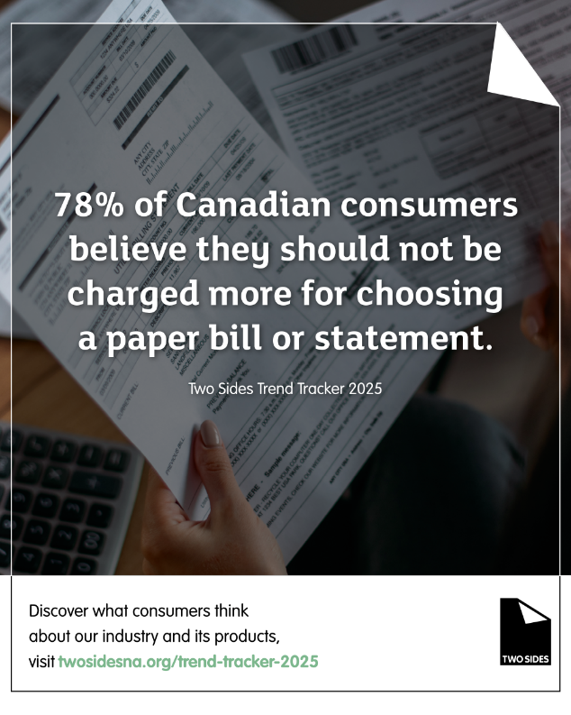
May 21st  LP | Instagram  Facebook  LinkedIn | In today’s hyper-connected world, the idea of being without your phone, smartwatch, or laptop is unthinkable. Our digital devices have revolutionized how we work, communicate, and stay informed.  Paper minimizes distractions. Digital devices constantly demand our attention, breaking our focus. Working with paper and pen offers a distraction-free environment so you can stay in the flow.  Read the @TwoSidesNA blog post, Paper: A Simple Solution to Those Digital Distractions, to discover how paper can be a simple solution to digital distractions and boost workplace efficiency.  Paper: A Simple Solution to Those Digital Distractions | Love Paper - North America | 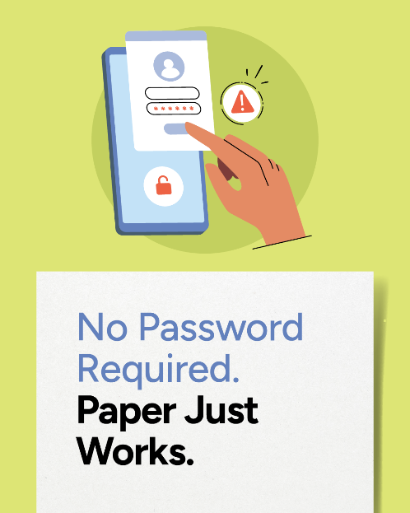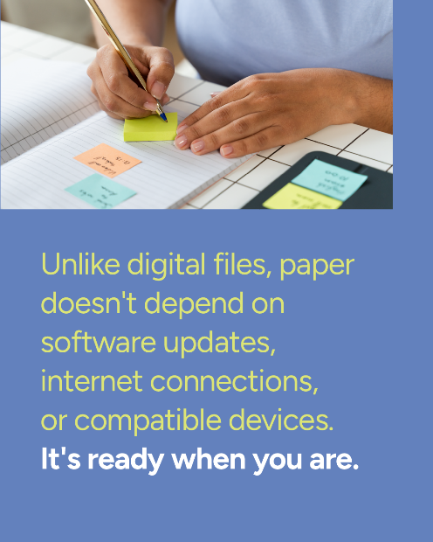
May 27  TSNA | X (Twitter)  Instagram  Facebook  LinkedIn | Did you know that only 16% of U.S. consumers realize our forests are thriving and expanding?🌲🌲🌲🌲🌲  Between 2000 and 2025, our forests will have grown by an astonishing 10 million acres!  Get more facts in the @TwoSidesNA Trend Tracker Survey!  https://twosidesna.org/trend-tracker-2025/  #trendtracker #paper #paperfacts #forestry #forest | 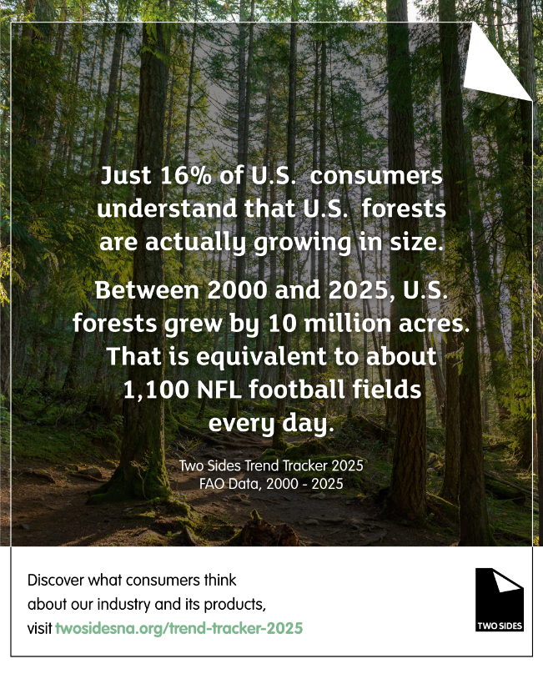
May 28  TSNA | X (Twitter)  Instagram  Facebook  LinkedIn | 96% of all Canadians now have access to recycling of corrugated boxes, paperboard or boxboard cartons, and kraft paper bags. Recycling paper means it can be reused again and again to make new paper products. Learn more!  https://twosidesna.org/canada-high-paper-recycling-rate  #recycle #paperfacts #paperbags #cardboard #boxes | 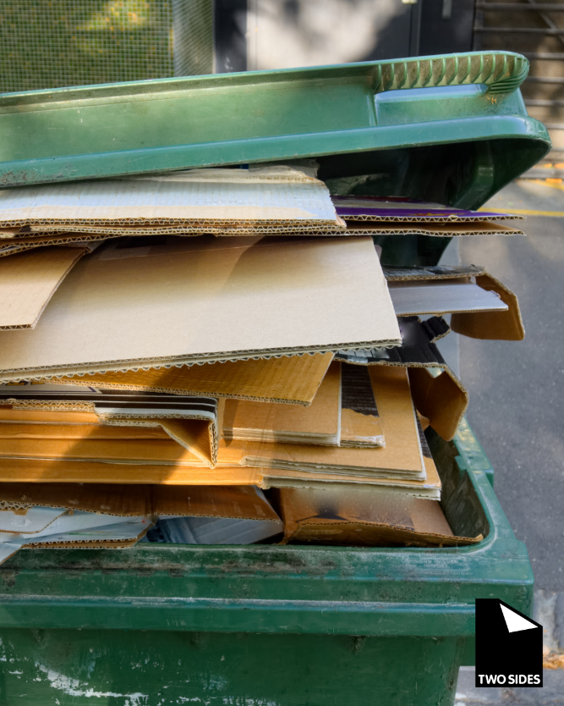
May 28th  LP | Instagram  Facebook  LinkedIn | When it matters most, put it on paper.  From heartfelt notes to important documents, paper makes every message more meaningful, memorable, and real.  Because some things deserve more than a screen.  www.lovepaperna.org  #LovePaper #PaperMatters #SustainableChoices | 